**Specific Leaf Area, Using ImageJ**

Written 6/2020 by CMP

Image J can be downloaded for free from the NIH website:

https://imagej.nih.gov/ij/download.html

Tips:

* Place your leaf on a white background for the best contrast. Filter paper works well, as it is slightly absorbent and won’t get as soggy as printer paper.
* The scale should be a strong color, that shows up well against the white background. Use dark colored lab tape, or dark colored paper (red works well). Do not use shiny tape to attach it to the white paper, as the glare will cause problems when analyzing the image later.
* Take photos in good lighting. Do your best to avoid having any shadow cover the leaf and scale in the image.
* Try to take the photos from directly above, to avoid warping of the image.
* Try to take the photos from about the same height (< 1 ft is best).
* For the most accurate measurement, you will want the leaf to be as flat as possible against the background. If you have a very curly leaf, you may need to hold it down with a thin object, such as tweezers, and later edit the image.
* Include the plant ID in the image. This will make it easier to match the image with the correct data later on.

Taking the photos

1. Start with a fresh piece of white background paper.
2. For your scale item, cut out a perfect 1cm x 1cm square and attach to the white paper.
3. Remove the leaf from the plant. Place the leaf on the paper near the scale. Do not cover the scale.
4. Include the plant tag, labeled coin envelope, or other item showing the Plant ID in the photo. This will help you identify which photo goes with which plant later on.
5. Take the photo straight above. Avoid shadows (see *tips*).
6. Place the leaf in the coin envelope and continue with other plants.

Below is a sample photo.

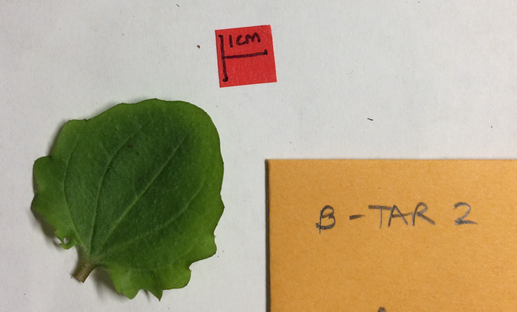

Oven-drying Leaves

1. Place the leaf in a labeled coin envelope.
2. Put the envelopes in the drying oven, set at 65*C.
3. Dry for 48 hours.
4. Remove the leaves from the oven in small batches. They will begin to absorb moisture from the air immediately, so it is best to work with small batches, and leave the rest in the oven.
5. Record the plant ID and dry weight in a lab notebook.

Analyzing the images in ImageJ

1. Upload the images from your phone or camera. Save all your images as .jpg files in a folder.
2. Open the ImageJ software.
3. Chose File > Open, then choose your correct folder and image in the pop up window.
4. Use the magnifying glass tool if necessary to zoom in enough to see the edges of your scale and leaf clearly.

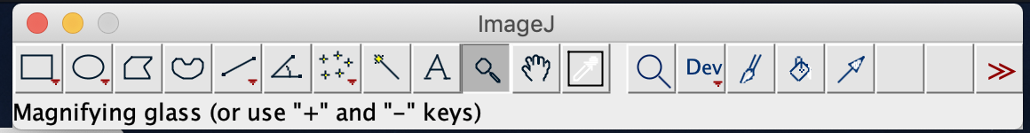

1. Use the straight line tool to draw a line along one edge of your scale.

 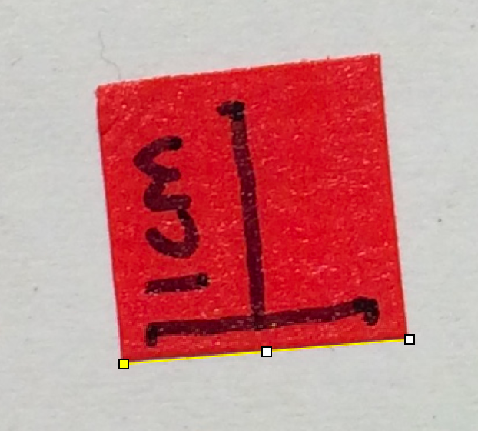

1. Choose Analyze > Set Scale. In the “Known Distance” box, type “1.” You can make the unit “cm” but this is not necessary. Do NOT choose “global.”[1]**

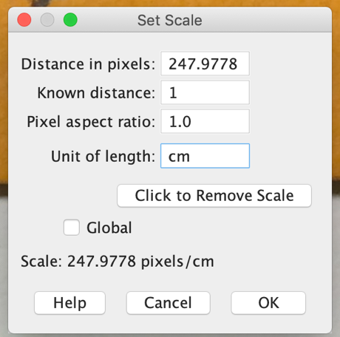

1. Choose Image > Adjust > Color Threshold. Unclick the box for “Dark Background.”

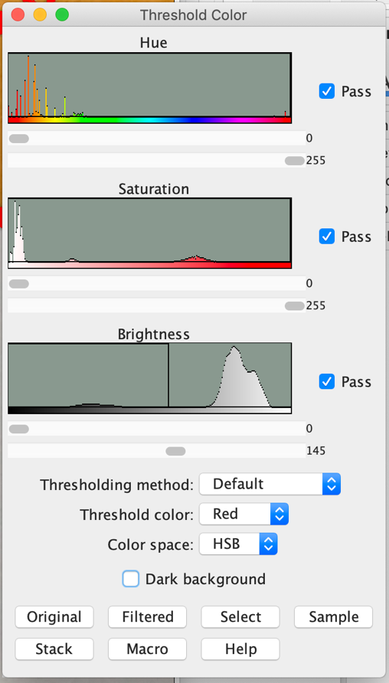

1. Slide the two scales beneath the Brightness box until your leaf is red, the background is mostly white, and the leaf border has a distinct edge from the background.

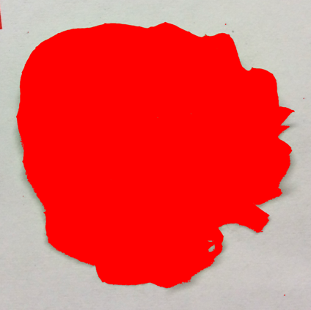

1. Choose Analyze > Tools > ROI Manager. A new window will appear (ROI Manager).

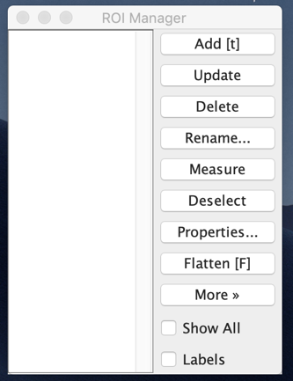

1. Select the wand icon from the toolbar. Click on your red leaf. It should highlight the perimeter of the leaf.

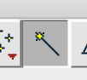

1. In the ROI manager window, click “Add.” Then click “Measure.” A new window will appear (Results). The area of your leaf (in cm2) will be listed in the first column. Copy and paste these results into Excel, labeling the row with the Plant ID.
2. If you would like to double check the accuracy of your measurements, you can find the surface area of your known 1cm2 scale. Use the square tool, or the polygon tool to trace the perimeter of your scale. Add and Measure it using the ROI manager. You should get an area that is very close to 1.
3. I find it easiest to close the Results window (Don’t Save), and delete all entries from the ROI Manager between images.
4. Close out of the image window. You can save the manipulated image if you wish. Otherwise, close the image, then open the next to continue.

Troublesome Images

Two common problems will mean you have to edit your image before you can use the automatic features of the software. If ImageJ cannot distinguish between the edge of the leaf and the background when you adjust the color threshold, this is usually due to poor image quality, low lighting, or shadows. There may also be times you need to edit out the tweezers your used to hold down a curly leaf. The following instructions will work for both problems.

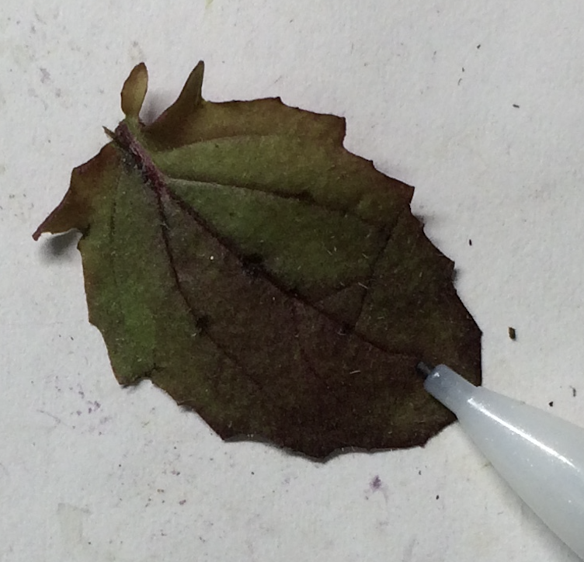

* 1. Choose the Color Picker tool from the toolbar.

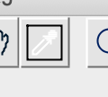

* 1. Click somewhere on the white background in the image. A lighter part is better.
  2. Choose the paintbrush tool.
  3. Carefully paint along the edge of the leaf, painting over any shadow, or the tweezers. You do not need to paint over the entire shadow or tweezers. Just make a line thick enough to make a distinct gap between the leaf and the darker background. Once there is a distinct color difference the software should be able to distinguish between the two.
     1. You do not necessarily need to go around the whole leaf border.

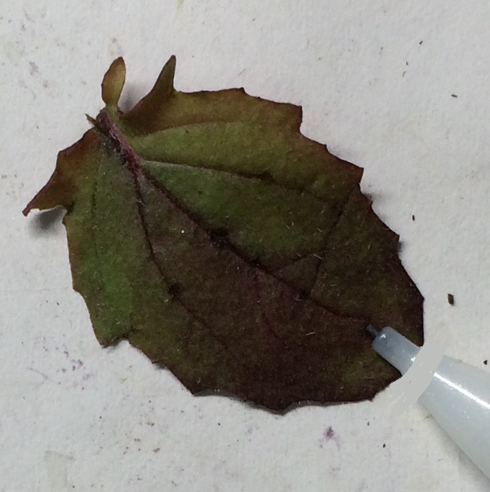

* 1. Try to use the color threshold and wand tools again. If you are still having trouble, you may need to paint over even more.
  2. Alternatively, you can use the Freehand Selection tool to hand trace the perimeter of your leaf.

Finding Specific Leaf Area

SLA (cm2 ⋅ g-1) = leaf area (cm2) / oven-dry weight (g)

1. ** Many internet tutorials will tell you to check to box for ‘global.’ However, you can only use the global scale if your scale icon will be the exact same amount of pixels in every photo. Because we do not use a tripod or other permanently attached holder, our camera is in a different place in every photo. The image quality can also change. This will affect the number of pixels per inch. You will need to set the scale uniquely for every photo.